After the Menu bar is created click on + next to the Application Toolbar.

Enter as shown below.

Here ADD, SUBT, MULT, DIVI and EXIT are the same FCT codes which have been given in the Menu Bar created earlier.

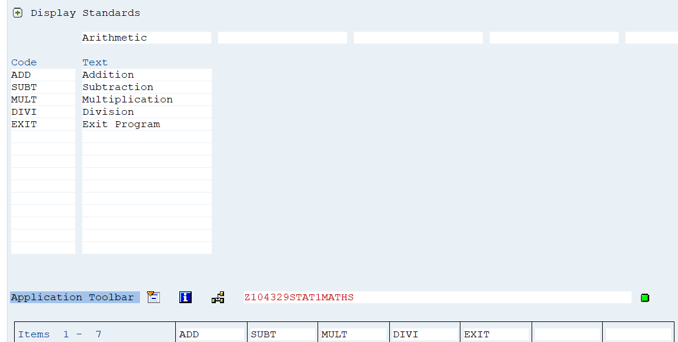

Double click on ADD. Assign function key.

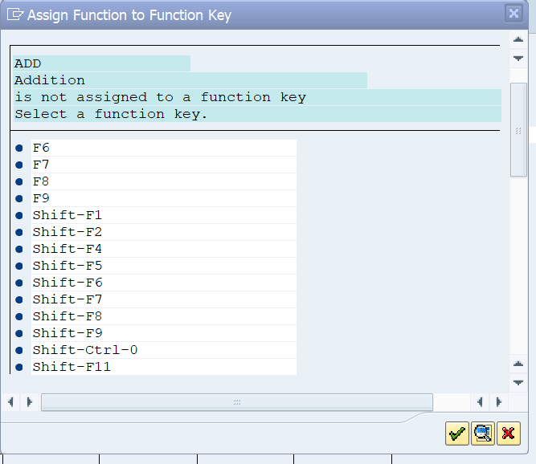

Similarly assign function keys for all Menu Items.

Enter Function Text. This is seen if no Icon is given.

Optionally enter Icon Name,

